1.4.7 Packet Tracer - Configure Router Interfaces
Addressing Table
Device | Interface | IP Address/Prefix | Default Gateway
R1 | G0/0 | 172.16.20.1 /25 | N/A
 | G0/1 | 172.16.20.129 /25 | N/A
 | S0/0/0 | 209.165.200.225 /30 | N/A
PC1 | NIC | 172.16.20.10 /25 | 172.16.20.1
PC2 | NIC | 172.16.20.138 /25 | 172.16.20.129
R2 | G0/0 | 2001:db8:c0de:12::1/64 | N/A
 | G0/1 | 2001:db8:c0de:13::1/64 | N/A
 | S0/0/1 | 2001:db8:c0de:11::1/64 | N/A
 |  | fe80::2 | N/A
PC3 | NIC | 2001:db8:c0de:12::a/64 | fe80::2
PC4 | NIC | 2001:db8:c0de:13::a/64 | fe80::2

Objectives
Part 1: Configure IPv4 Addressing and Verify Connectivity
Part 2: Configure IPv6 Addressing and Verify Connectivity

Background
Routers R1 and R2 each have two LANs. Your task is to configure the appropriate addressing on each device and verify connectivity between the LANs.
Note: The user EXEC password is cisco. The privileged EXEC password is class.

Instructions

Part 1: Configure IPv4 Addressing and Verify Connectivity

Step 1: Assign IPv4 addresses to R1 and LAN devices.
Referring to the Addressing Table, configure IP addressing for R1 LAN interfaces, PC1 and PC2. The serial interface has already been configured.

R1 > CLI  - Password: cisco  - R1>enable  - Password: class  - R1#configure terminal  - R1(config)#int g 0/0  - R1(config-if)#ip address 172.16.20.1 255.255.255.128  - R1(config-if)#no shutdown  - R1(config-if)#exit  - R1(config)#int g 0/1  - R1(config-if)#ip address 172.16.20.129 255.255.255.128  - R1(config-if)#no shutdown | 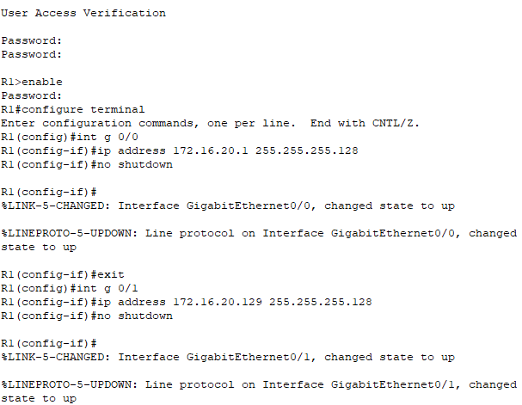
PC1 > Desktop > IP Configuration  IPv4 Address : 172.16.20.10  Subnet Mask : 255.255.255.128  Default Gateway : 172.16.20.1 | 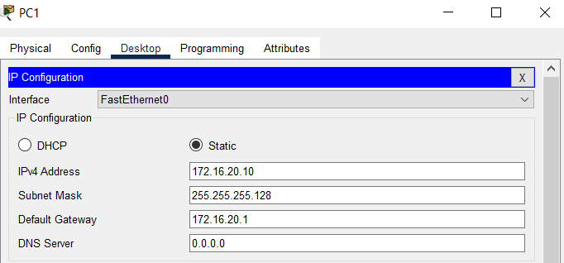
PC2 > Desktop > IP Configuration  IPv4 Address : 172.16.20.138  Subnet Mask : 255.255.255.128  Default Gateway : 172.16.20.129 | 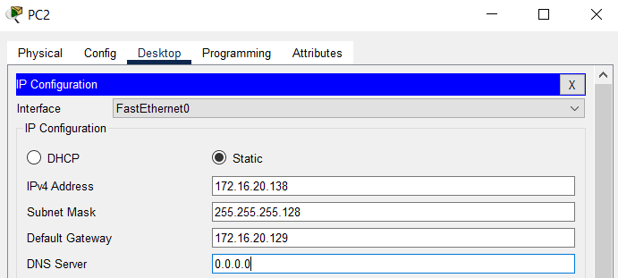

Step 2: Verify connectivity.
PC1 and PC2 should be able to ping each other and the Dual Stack Server.

PC1 > Command Prompt  C:\>ping 172.16.20.138  C:\>ping 64.100.1.10 | 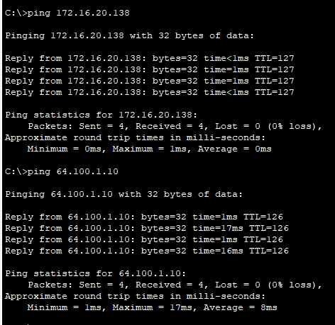
PC2 > Command Prompt  C:\>ping 172.16.20.10  C:\>ping 64.100.1.10 | 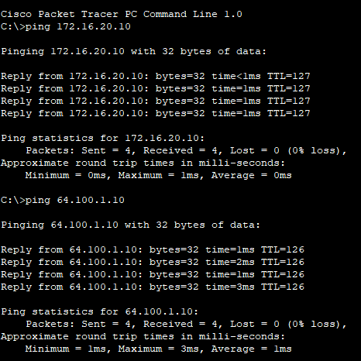

Part 2: Configure IPv6 Addressing and Verify Connectivity

Step 1: Assign IPv6 addresses to R2 and LAN devices.
Referring to the Addressing Table, configure IP addressing for R2 LAN interfaces, PC3 and PC4. The serial interface is already configured.

R2 > CLI  - Password: cisco  - R1>enable  - Password: class  - R1#configure terminal  - R1(config)# int g 0/0  - R1(config-if)#ipv6 address 2001:db8:c0de:12::1/64  - R1(config-if)#ipv6 address fe80::2 link-local  - R1(config-if)#no shutdown  - R1(config-if)#exit  - R1(config)#int g 0/1  - R1(config-if)#ipv6 address 2001:db8:c0de:13::1/64  - R1(config-if)#ipv6 address fe80::2 link-local  - R1(config-if)#no shutdown | 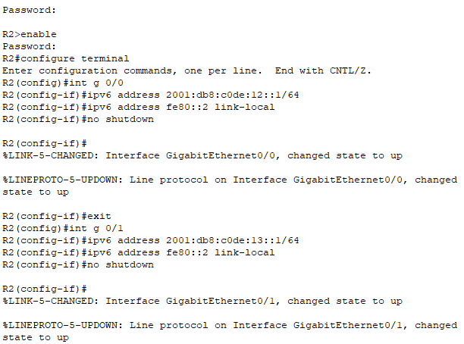
PC3 > Desktop > IP Configuration  IPv6 Address : 2001:db8:c0de:12::a/64  Default Gateway : fe80::2 | 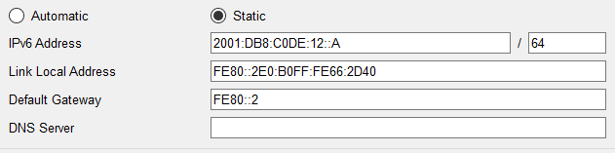
PC4 > Desktop > IP Configuration  IPv6 Address : 2001:db8:c0de:13::a/64  Default Gateway : fe80::2 | 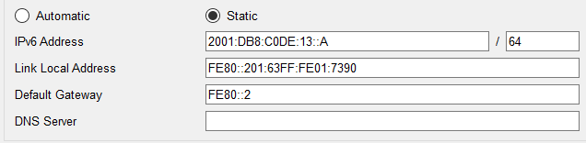

Step 2: Verify connectivity.
PC3 and PC4 should be able to ping each other and the Dual Stack Server.

PC3 > Command Prompt  C:\>ping 2001:db8:c0de:13::a  C:\>ping 2001:db8:100:1::a | 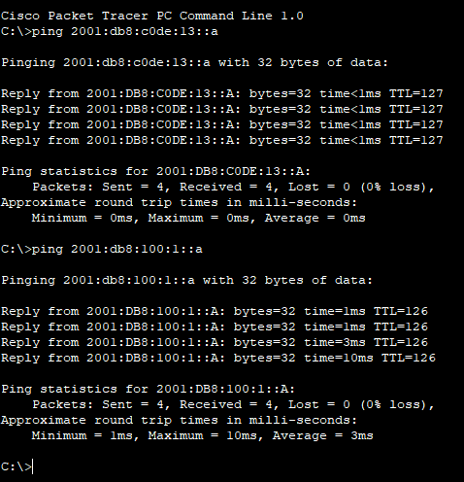
PC4 > Command Prompt  C:\>ping 2001:db8:c0de:12::a  C:\>ping 2001:db8:100:1::a | 